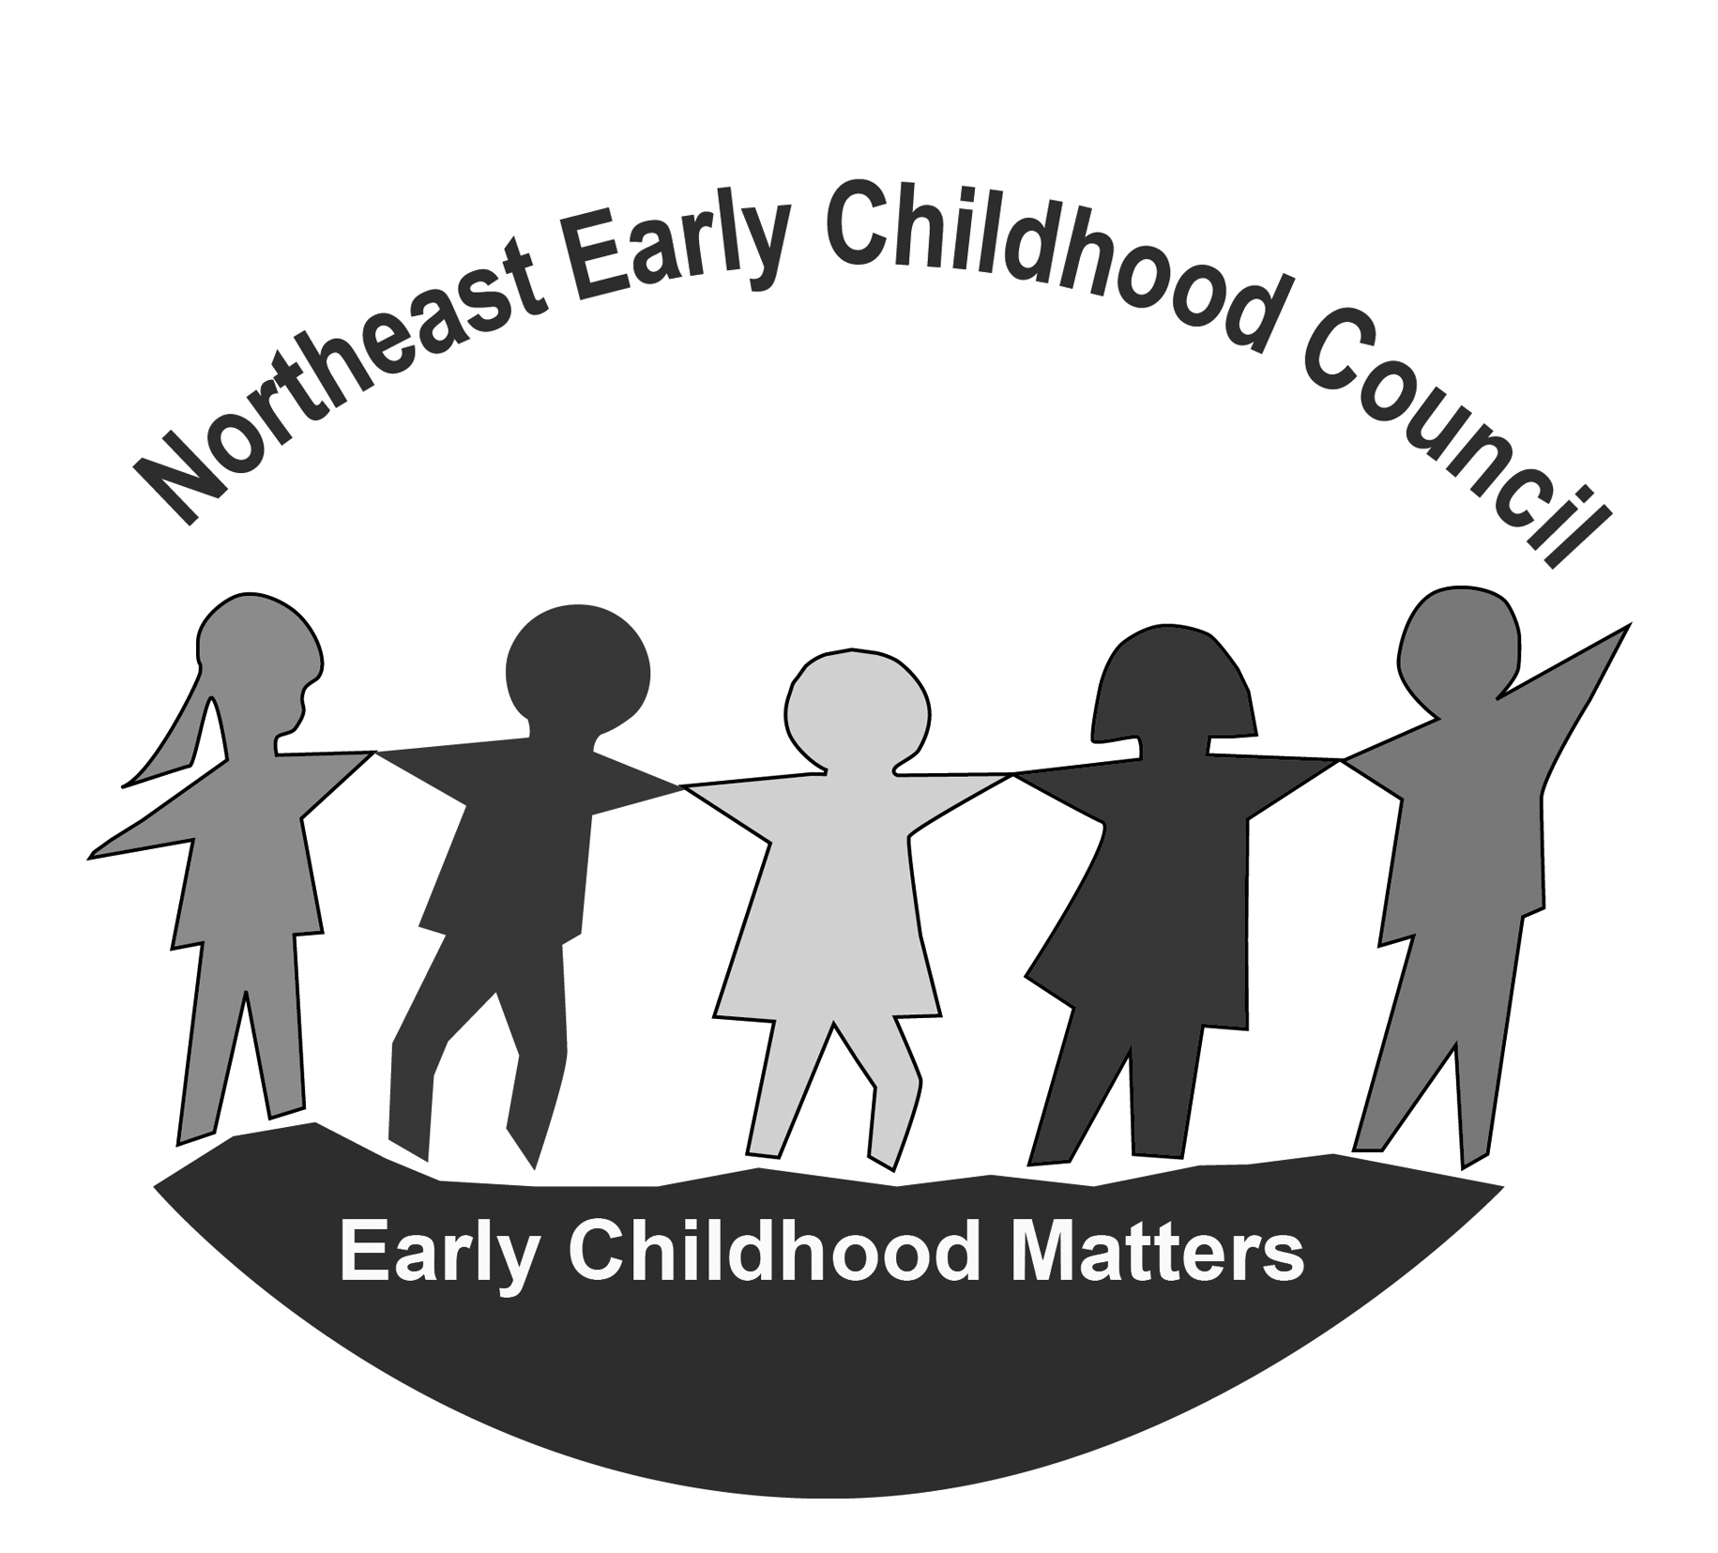
NORTHEAST EARLY CHILDHOOD COUNCIL
Monday, January 23rd, 2023
5:30 p.m. – 7:00 p.m.
Online – Zoom

https://us02web.zoom.us/j/84148948682?pwd=VmgydzhQUnVDbmtpY1YwdlVKRi8vdz09

Meeting ID: 841 4894 8682 Passcode: 330543

AGENDA
Time | Item | Person Responsible | Outcome
5:30 pm | Welcome & Introductions | Co-Chairs
5:35 pm | Guest Speakers  - SERAC – Negative impact of vaping, edibles and marijuana use from adults on young children in the home  - ACCESS Agency: 2-1-1/Homeless Prevention system, and the Department of Housing new eviction prevention programs | Jennifer Buckley  & Emma King | Members Informed & Q&A
6:05 pm | NECC Staff Updates | Kris & Chris | Members Informed
6:15 pm | Regional Program / Community Updates | NECC Partners | Members Informed & Sharing resources
6:25 pm-7:00 pm | School Readiness  - Approval of Notes  - Review of a quality component from the NECC SR Program Meeting  - Fiscal Items:  - Expenditure Reports (SR/QE)  - Family Fee expenditure reports  - Proposed budget revisions (SR/QE)  - Liaison Updates  - OEC Info  - Monitoring Info  - Pertinent Program Updates  - Collaboration Agreements  - Parent Feedback/Input/Questions  - When it comes to your family’s (or families you know) physical and/or mental health, what is affecting your child's ability to learn and what help is needed?  - Agenda items for next meeting generated  https://drive.google.com/drive/u/1/folders/1aj_rDFhUQnvmUAi1GKbGZvXVbTHZo5kJ | Liaisons | School Readiness Council Business accomplished

