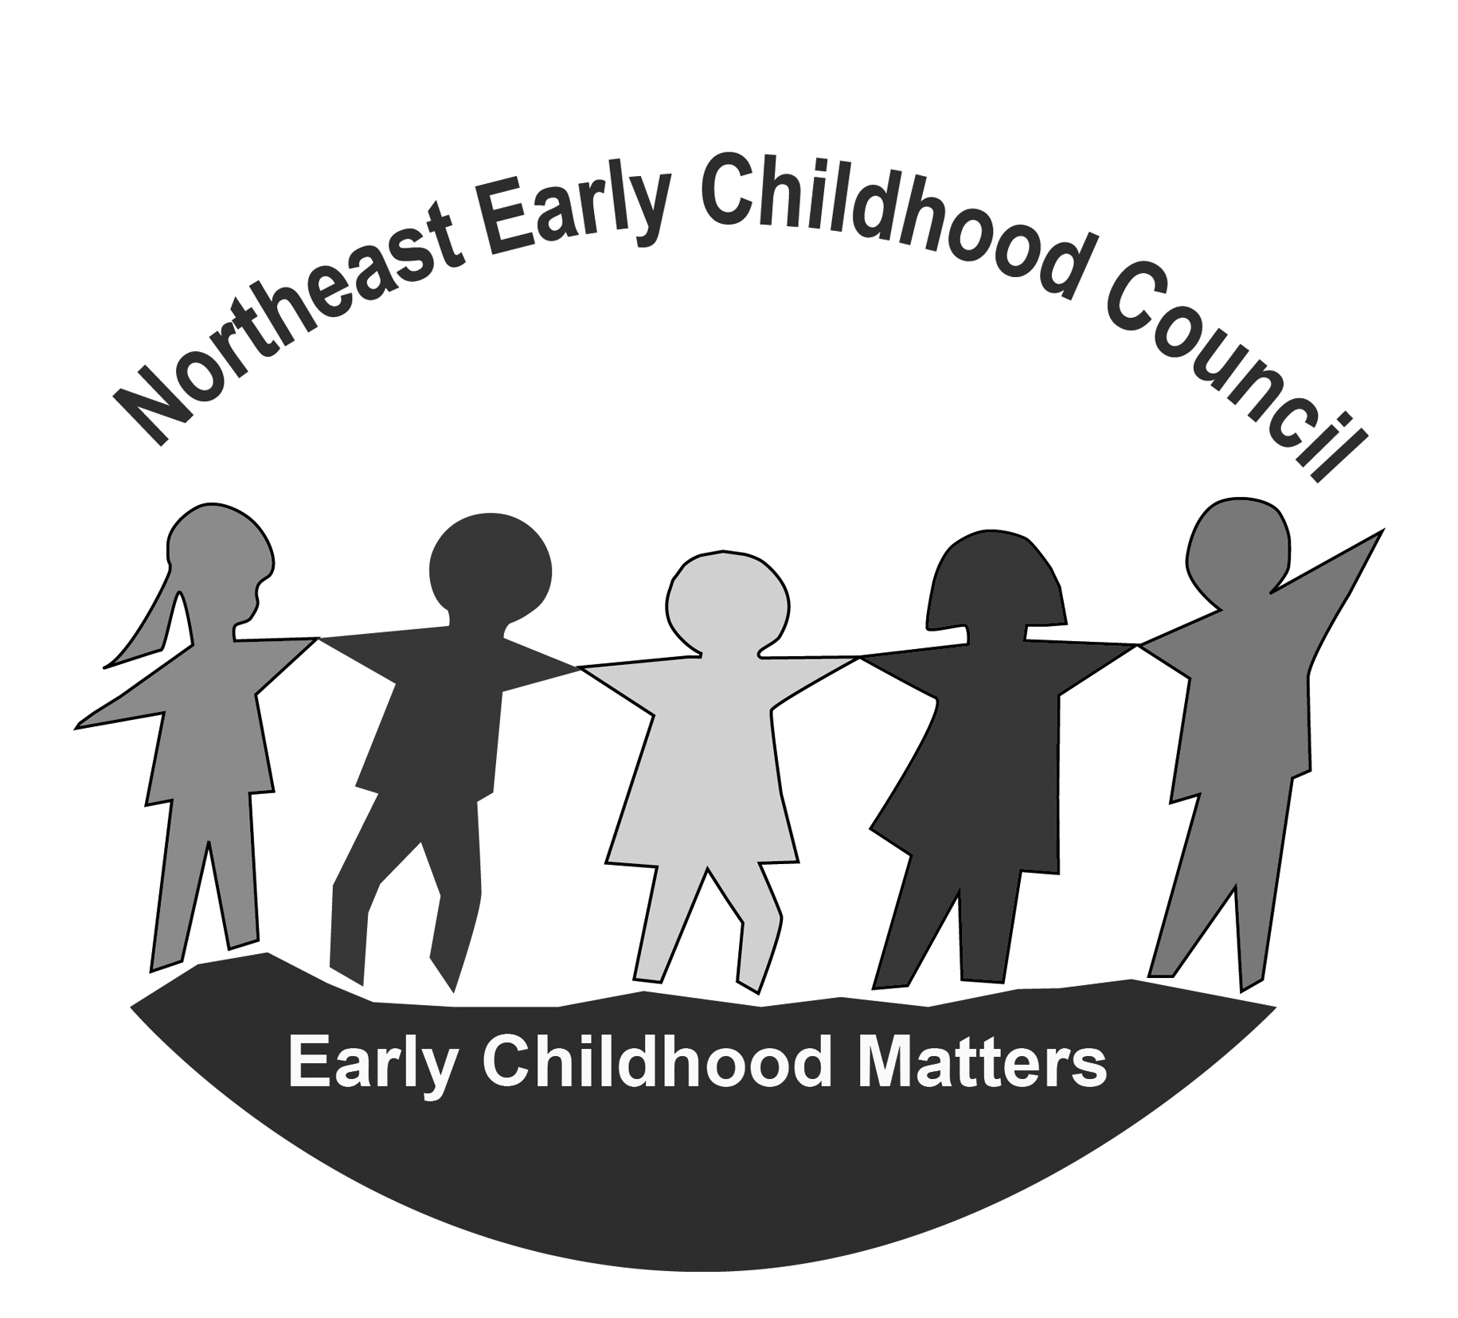
NORTHEAST EARLY CHILDHOOD COUNCIL
Monday, March 13th, 2023
5:30 p.m. – 7:00 p.m.
Online – Zoom

https://us02web.zoom.us/j/84148948682?pwd=VmgydzhQUnVDbmtpY1YwdlVKRi8vdz09

Meeting ID: 841 4894 8682 Passcode: 330543

AGENDA
Time | Item | Person Responsible | Outcome
5:30 pm | Welcome & Introductions | Co-Chairs
5:35 pm | Guest Speaker: CPAC: Connecticut Parent Advocacy Center, Inc. | Jane Hampton | Members Informed & Q&A
6:00 pm | NECC Staff Updates | Kris & Chris | Members Informed
6:10 pm | Regional Program / Community Updates | NECC Partners | Members Informed & Sharing resources
6:20 pm-7:00 pm | School Readiness  - Approval of Notes  - Review of a quality component from the NECC SR Program Meeting  - Fiscal Items:  - Expenditure Reports (SR/QE)  - Family Fee expenditure reports  - Proposed budget revisions (SR/QE)  - Liaison Updates  - OEC Info  - Monitoring Info  - Pertinent Program Updates  - Collaboration Agreements  - Parent Feedback/Input/Questions  If a free workshop was offered around social-emotional learning for parents of young children to help their child identify emotions, build relationships, communicate effectively, and much more, would you be interested in attending? If yes, what specific areas would you be most interested in?  - Voting on polices  - Agenda items for next meeting generated  https://drive.google.com/drive/u/1/folders/1aj_rDFhUQnvmUAi1GKbGZvXVbTHZo5kJ | Liaisons | School Readiness Council Business accomplished

