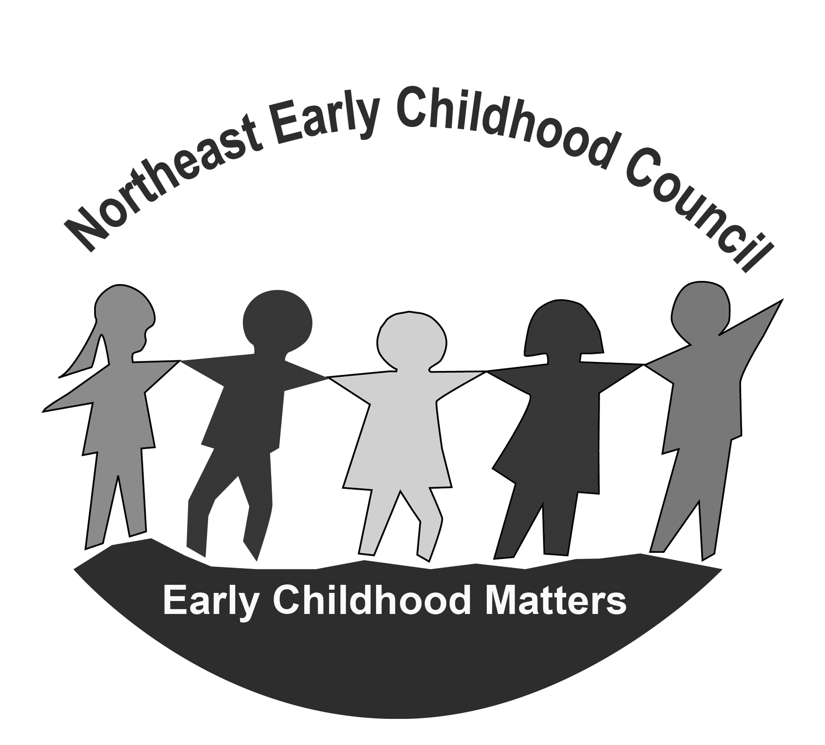
NORTHEAST EARLY CHILDHOOD COUNCIL
Monday, September 19th, 2022
5:30 p.m. – 7:00 p.m.
Online – Zoom

https://us02web.zoom.us/j/84148948682?pwd=VmgydzhQUnVDbmtpY1YwdlVKRi8vdz09

Meeting ID: 841 4894 8682
Passcode: 330543

AGENDA

Time | Item | Person Responsible | Outcome
5:30 pm | Welcome & Introductions | Co-Chairs
5:35 pm | Guest Speaker – United Way  Mental Health Resources | Heather Spada | Members Informed & Q&A
5:55 pm | NECC Staff Updates | Kris Cicchetti/  Chris Rosati Randall | Members Informed
6:05 pm | Regional Program / Community Updates | NECC Partners | Members Informed & Sharing of resources
6:15 pm-7:30 pm | School Readiness Council Meeting  Find Agenda and related documents:  https://drive.google.com/drive/folders/1B4JPZVaFWXDuSNkbPl7r2489YcYUgdb6?usp=sharing | Liaisons | School Readiness Council Business accomplished

